Experiment 22 : Shell Programming in Kali Linux
i) Program to Read a Number and Find Its Square
1. Aim
To write and execute a shell script to read a number from the user and calculate its square.
2. Algorithm
- Start the program.
- Read a number from the user.
- Calculate the square by multiplying the number by itself.
- Display the calculated square.
- Stop the program.
3. Code
File name: square.sh
#!/bin/bash

echo "Enter a number:"
read num

square=$((num * num))

echo "Square of $num is $square"
4. Execution Commands
nano square.sh
Save the code and execute:
chmod +x square.sh
./square.sh
- Output
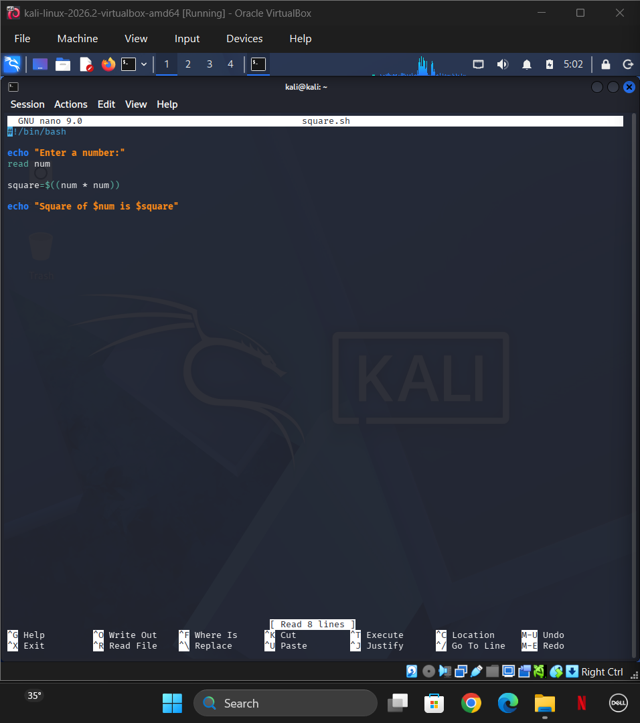
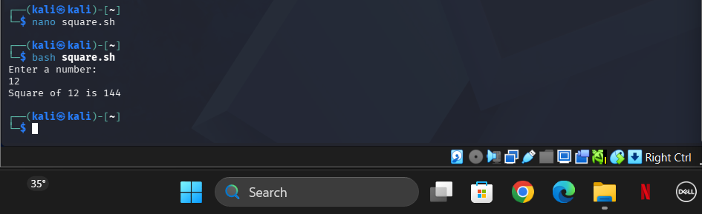
6. Result
Thus, the shell script was successfully executed to read a number and calculate its square.

ii) Program to Find the Biggest of Three Numbers
1. Aim
To write and execute a shell script to find the biggest number among three given numbers using conditional statements.
2. Algorithm
- Start the program.
- Read three numbers from the user.
- Compare the first number with the second and third numbers.
- If the first number is greater than or equal to both, display it as the biggest.
- Otherwise, compare the second number with the first and third numbers.
- If the second number is greater than or equal to both, display it as the biggest.
- Otherwise, display the third number as the biggest.
- Stop the program.
3. Code
File name: biggest.sh
#!/bin/bash

echo "Enter three numbers:"
read a
read b
read c

if [ $a -ge $b ] && [ $a -ge $c ]
then
echo "$a is the biggest number"

elif [ $b -ge $a ] && [ $b -ge $c ]
then
echo "$b is the biggest number"

else
echo "$c is the biggest number"
fi
4. Execution Commands
nano biggest.sh
Save the code and execute:
chmod +x biggest.sh
./biggest.sh
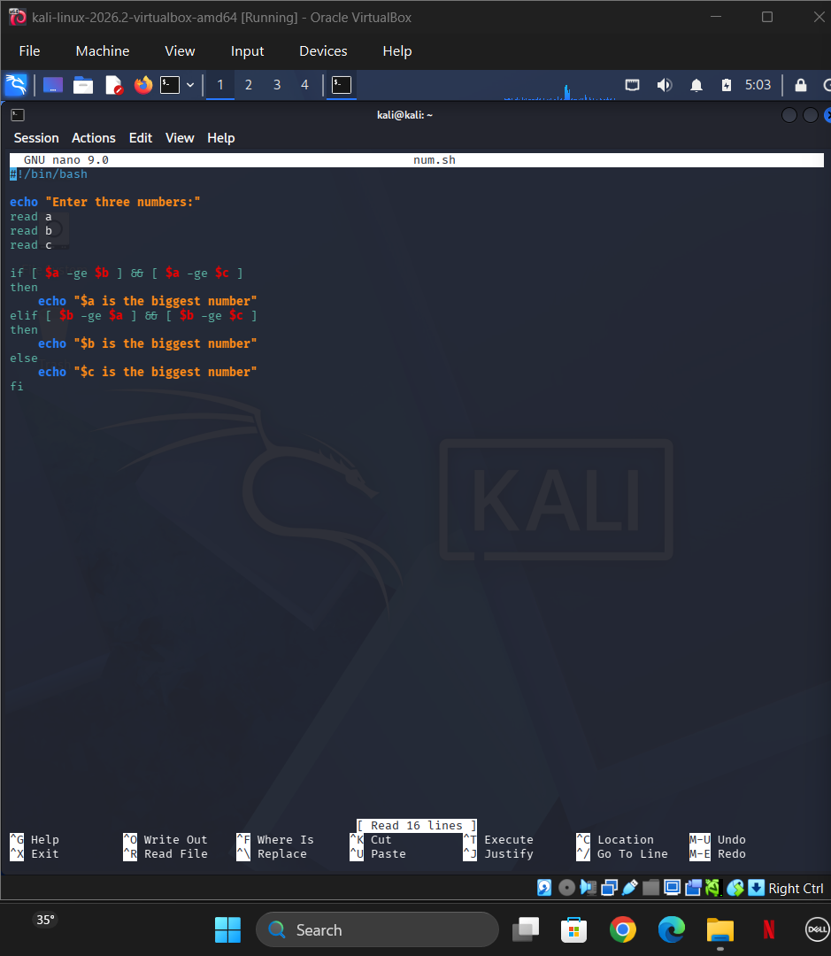
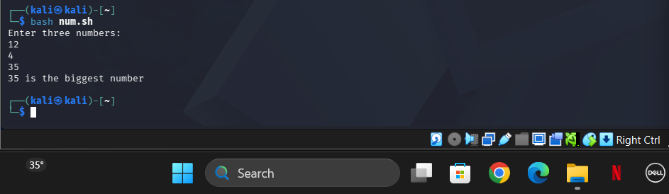
6. Result
Thus, the shell script was successfully executed to find the biggest number among three given numbers using conditional statements.
Note: Both programs can be executed directly in the Kali Linux terminal. Take screenshots of the code and output for your practical record.

